Database Fundamentals
- Create the table structure for your Database

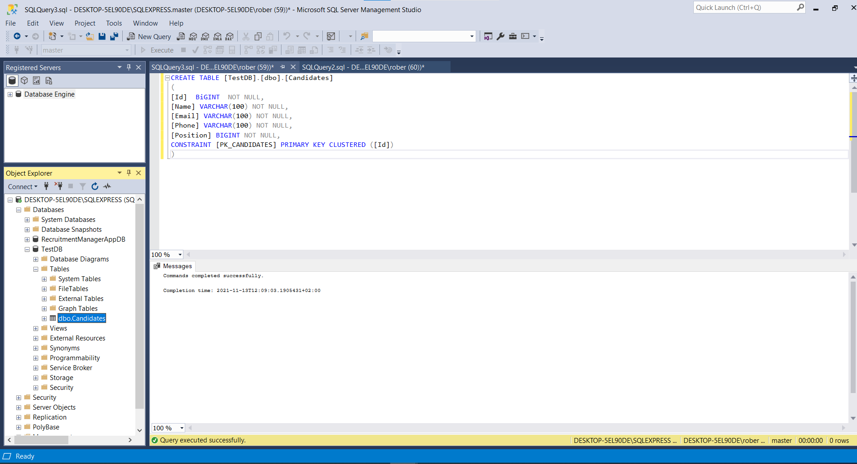

- Use Primary keys to enforce uniqueness

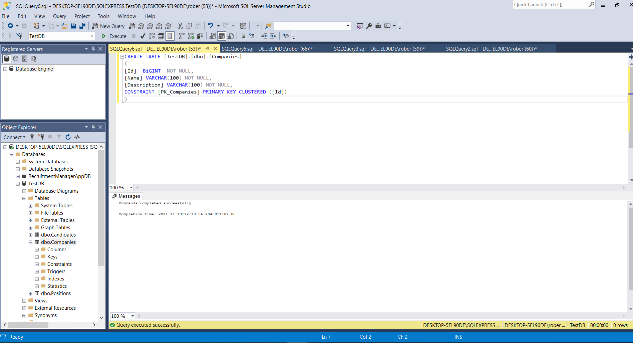

- Use foreign keys to enforce referential integrity

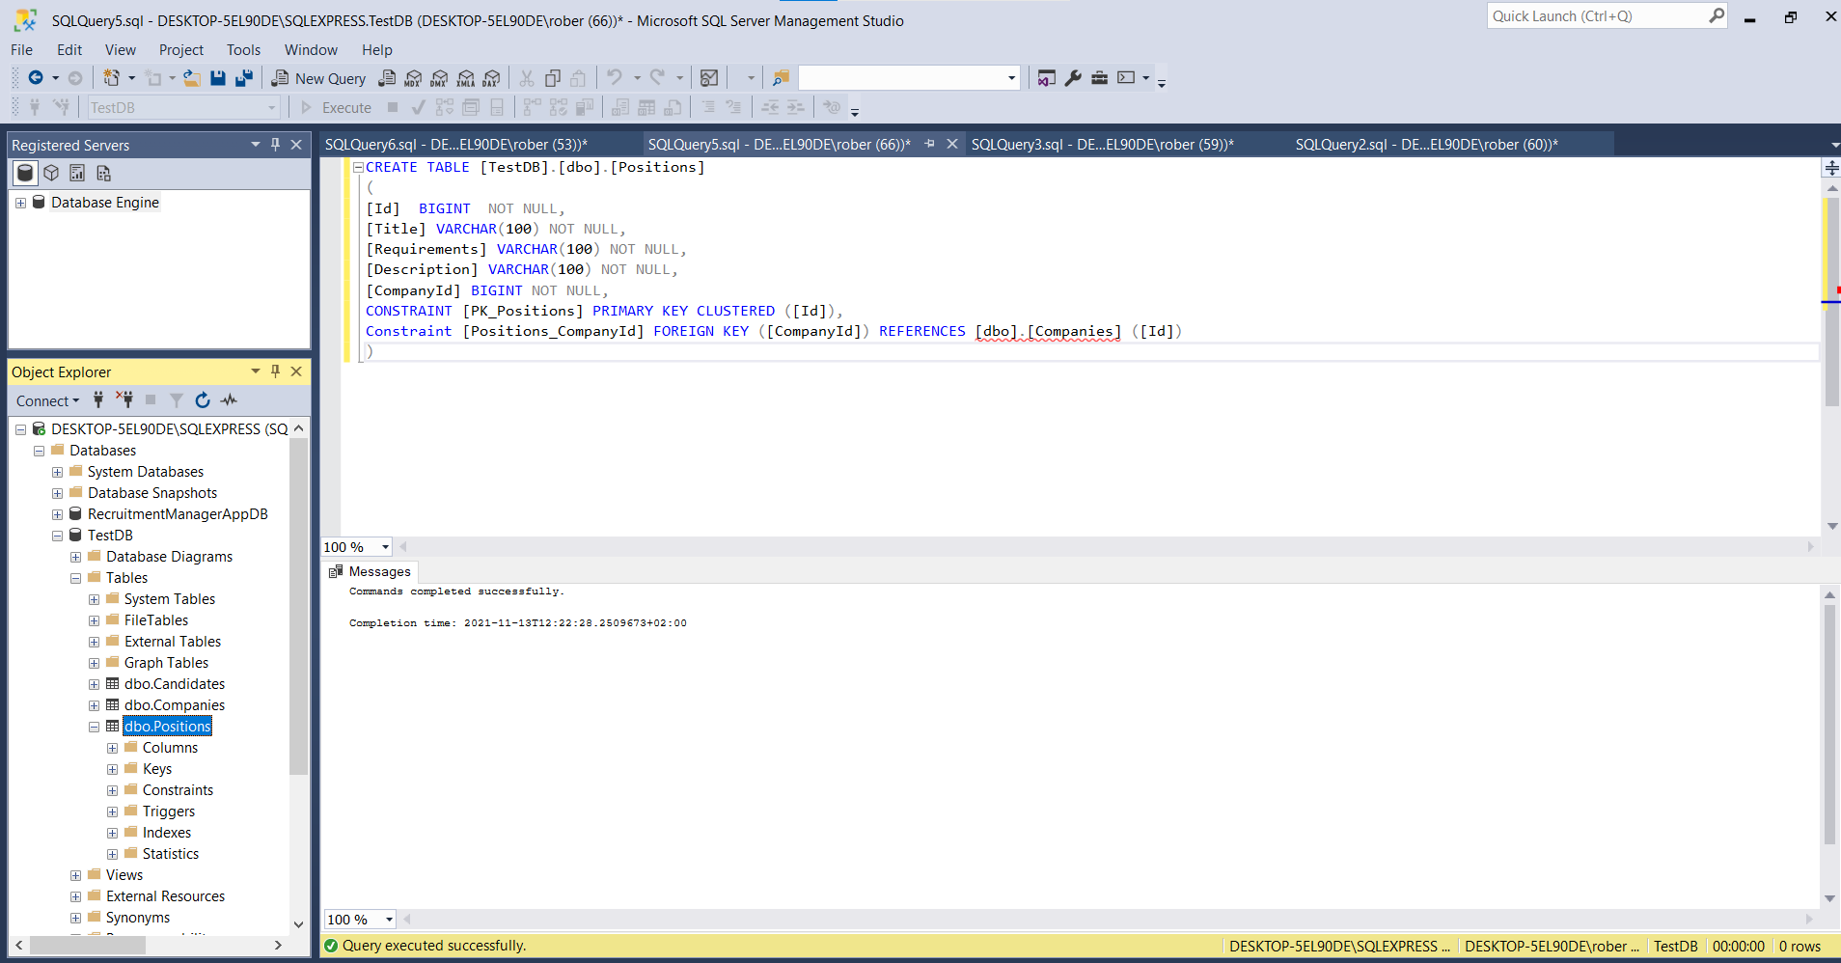

- Provide a script creating the database

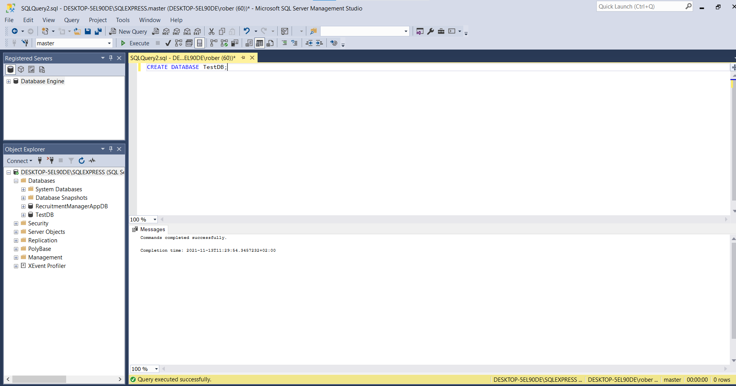

- Write Filtering queries

UnFiltered:
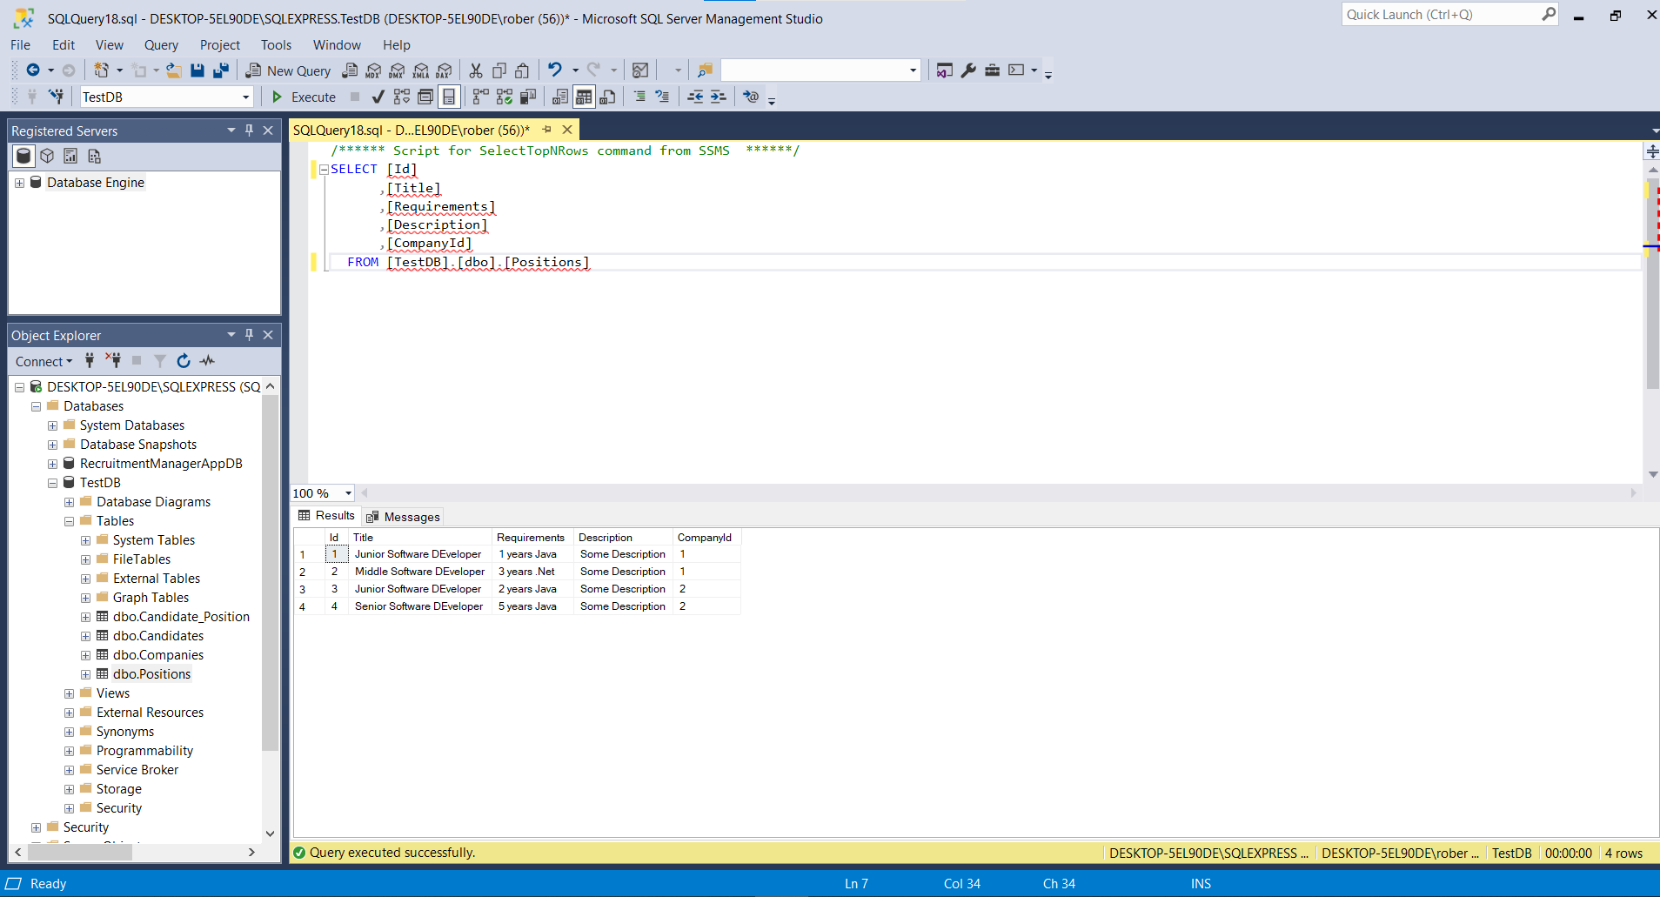
Filtered:
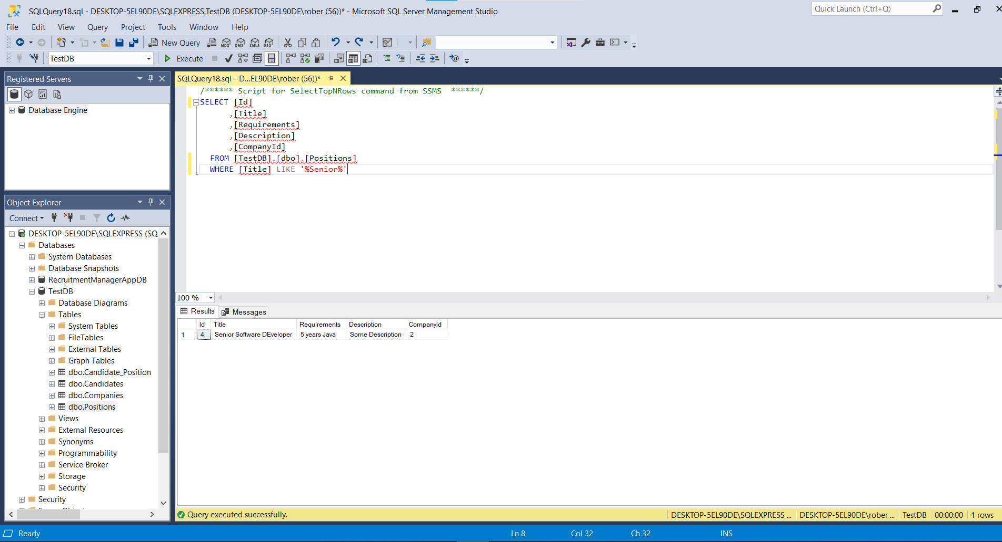

- Use Joining queries – inner join, outer joins.
Inner Join:
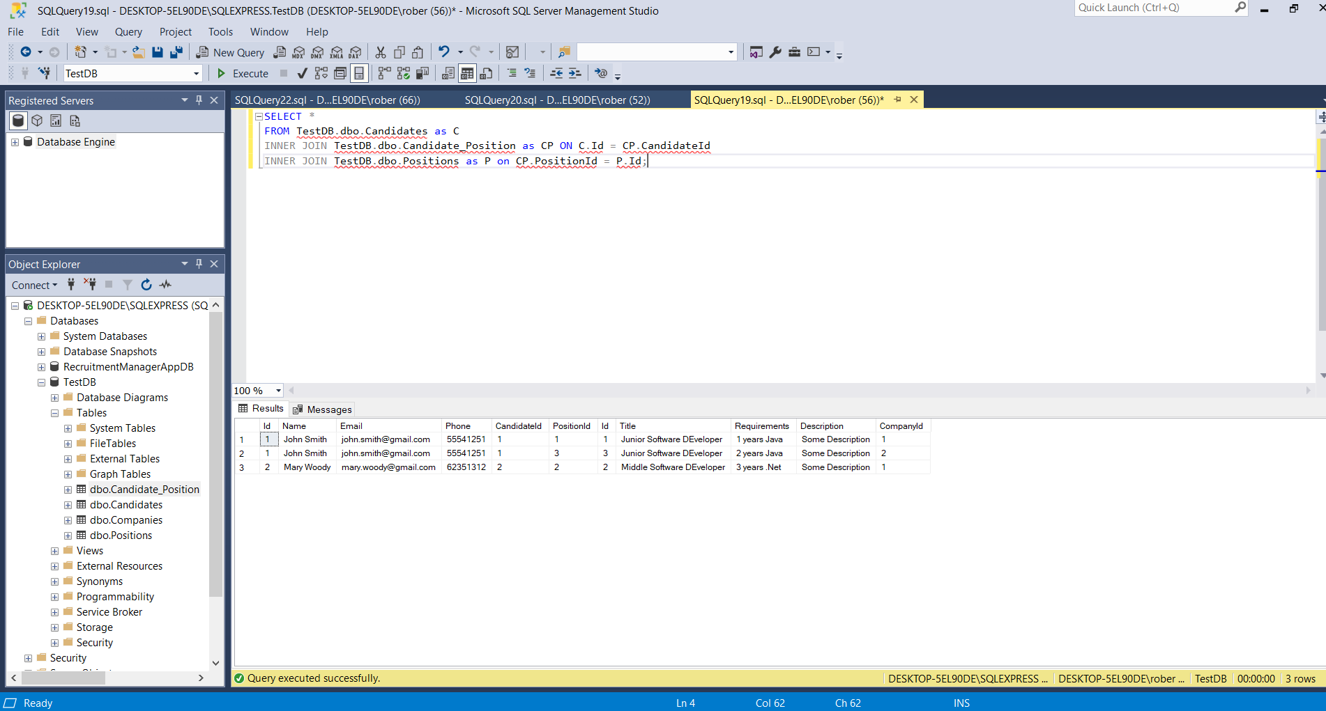
Outer Join + Order By:
